REVELATION 17–18
The Great Whore, Her Rule,
and Her Destruction
Adult Bible Study Student Handout • King James Version
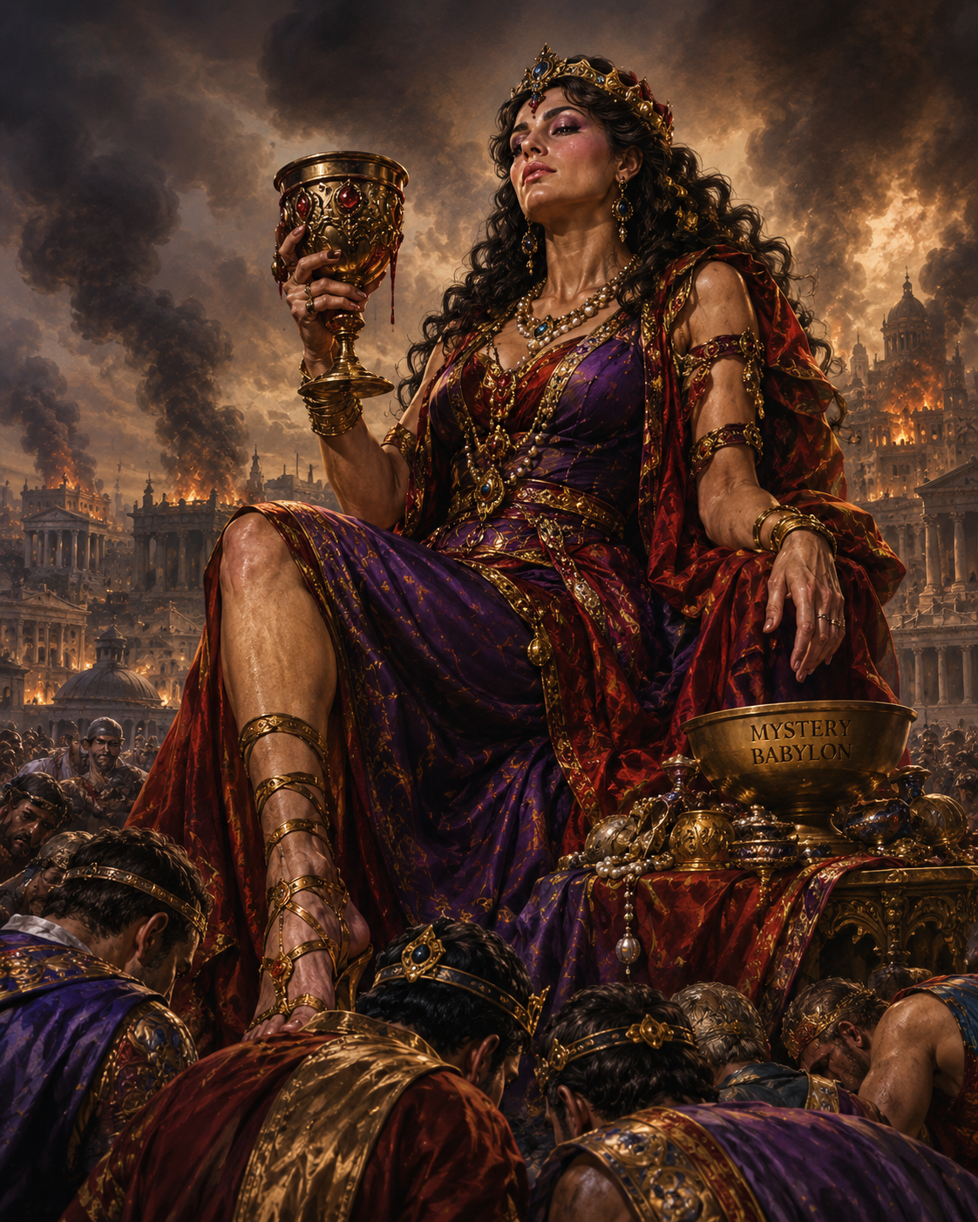
Central Truth
“These shall make war with the Lamb, and the Lamb shall overcome them: for he is Lord of lords, and King of kings.”
— Revelation 17:14 (KJV)

Lesson Plan and Learning Objectives
Primary Text | Revelation 17:1–18; Revelation 18:1–24
Related Texts | Genesis 11:1–9; Jeremiah 51:7; Daniel 2; John 15:18–20; Romans 12:1–2; 1 John 2:15–17
Theme | The seductive power, worldwide influence, judgment, and destruction of Mystery Babylon.
Lesson Aim | To distinguish the woman from the beast, explain her symbolic role, and apply the command to remain faithful to Christ.
Suggested Time | 60–75 minutes: opening 5; reading 10; exposition 35; discussion 15; application/prayer 10.

Learning Objectives
- Identify the woman, the waters, the beast, the seven heads, and the ten horns from the text.
- Explain the theological meaning of Babylon as organized human rebellion against God.
- Describe the alliance between corrupt religious influence, political power, and economic luxury.
- Explain why the Lamb’s victory is the doctrinal center of the chapter.
- Apply Revelation 18:4: “Come out of her, my people” without withdrawing from faithful witness in the world.

Important Textual Correction
The “great whore” is introduced in Revelation 17, not Revelation 13. Revelation 13 introduces the beast from the sea and the beast from the earth. Revelation 17 explains the woman’s relationship to the beast and the kings; Revelation 18 describes Babylon’s fall.

Opening Question
How can a system appear wealthy, religious, respectable, and powerful while being spiritually opposed to God?

I. The Judgment Announced — Revelation 17:1–2
The angel begins with the certainty of judgment. The woman “sitteth upon many waters.” Verse 15 interprets the waters as “peoples, and multitudes, and nations, and tongues.” Her influence is therefore international. Her fornication with kings pictures corrupt alliance, spiritual infidelity, and compromise with worldly power.
Doctrine: God judges spiritual adultery and every alliance that exchanges fidelity to Him for worldly power.

II. The Woman and the Scarlet Beast — Revelation 17:3
John sees a woman sitting upon a scarlet beast having seven heads and ten horns. The imagery connects Revelation 17 with Revelation 13. The woman and beast are related but are not identical: the woman rides the beast, indicating dependence upon and influence through political power.
Doctrine: Religious corruption and political rebellion can cooperate for a season, but evil alliances are unstable.

III. Purple, Scarlet, Gold, and the Golden Cup — Revelation 17:4
The woman appears magnificent: purple, scarlet, gold, precious stones, and pearls. Yet her golden cup is “full of abominations.” The contrast is theological: outward splendor can conceal inward corruption. Jeremiah 51:7 supplies important Babylon imagery.
Doctrine: Visible prosperity, ceremony, wealth, or influence is never proof of divine approval.

IV. “Mystery, Babylon the Great” — Revelation 17:5
Babylon functions as more than a geographic label. From Babel in Genesis 11 through imperial Babylon and into Revelation, Babylon becomes a biblical symbol of civilization organized in pride, idolatry, and rebellion against God.
Doctrine: Human systems become Babylon-like when they exalt themselves against God and demand the loyalty that belongs to Him.

V. Drunk With the Blood of the Saints — Revelation 17:6
The woman is not merely seductive; she is persecuting. She is “drunken with the blood of the saints.” The system that first attracts through wealth and influence ultimately opposes faithful witness.
Doctrine: Faithfulness to Christ can bring conflict with systems that tolerate religion only when it compromises.

VI. Seven Heads and Ten Horns — Revelation 17:7–13
The angel interprets the imagery. The seven heads are associated with seven mountains and seven kings; the ten horns are ten kings who give their power and strength unto the beast. Interpretive systems differ on specific historical identifications, so students should distinguish explicit biblical interpretation from later speculation.
Doctrine: Earthly kingdoms rise and fall; political authority is temporary and accountable to God.

VII. The Lamb Shall Overcome — Revelation 17:14
The kings make war with the Lamb, “and the Lamb shall overcome them.” This is the theological center of the chapter. Jesus is “Lord of lords, and King of kings.” The crucified Lamb is also the victorious universal King.
Christology: Christ possesses supreme authority. No empire, ruler, religious system, or spiritual power can finally defeat Him.

VIII. Her Rule Over the Nations — Revelation 17:15
The waters are explicitly interpreted as peoples, multitudes, nations, and tongues. Babylon’s reach crosses political, ethnic, linguistic, religious, and economic boundaries. Revelation 18 expands this picture through kings, merchants, luxury, and commerce.
Doctrine: Sin can become systemic, shaping institutions, cultures, economies, and governments as well as individual hearts.

IX. The Beast Turns Against the Woman — Revelation 17:16–17
The ten horns that supported the woman eventually hate and destroy her. Verse 17 emphasizes divine sovereignty: “For God hath put in their hearts to fulfil his will.” Their evil intentions remain their own, yet God overrules history toward His appointed judgment.
Doctrine: God is sovereign without becoming the author of evil. Rebellious powers cannot frustrate His final purpose.

X. The Great City and the Fall of Babylon — Revelation 17:18; 18:1–24
The woman is identified as “that great city, which reigneth over the kings of the earth.” Revelation 18 then announces, “Babylon the great is fallen, is fallen.” Kings, merchants, and traders mourn because the system that enriched them collapses; heaven rejoices because God has judged the persecuting power.
Doctrine: Every system built upon idolatry, exploitation, pride, persecution, and rebellion is temporary and subject to divine judgment.

Disciples Application — Revelation 18:4
“Come out of her, my people, that ye be not partakers of her sins…” — Revelation 18:4 (KJV)
The command is a call to spiritual separation from Babylon’s sins, not abandonment of Christian witness. Believers live in society without giving their worship, conscience, morality, or ultimate allegiance to systems opposed to God.

Major Doctrinal Themes
Sovereignty of God: Revelation 17:17 — God remains sovereign over nations and history.
Christology: Revelation 17:14 — Jesus Christ is Lord of lords and King of kings.
Sin and Idolatry: Babylon demonstrates that rebellion can be personal, cultural, political, religious, and economic.
Apostasy: Religious appearance is not equivalent to faithfulness to God.
Judgment: God’s patience must not be mistaken for indifference; Babylon’s fall is certain.
Church and Holiness: God’s people are called to faithful separation from sin while bearing witness to Christ.
Final Victory: The Lamb overcomes; the final word belongs to Christ, not Babylon.

Interpretive Caution
Disciples have interpreted Babylon in several ways: as imperial Rome in John’s historical setting, as a future end-time religious-political-economic system, or as the recurring biblical pattern of world civilization organized against God. The lesson should distinguish what Revelation explicitly states from attempts to identify every symbol with a modern institution.

Discussion Questions
- According to Revelation 17:15, what do the many waters represent?
- What does the woman’s clothing and wealth communicate about the attractiveness of Babylon?
- What does the golden cup teach about outward appearance and inward corruption?
- How are the woman and the beast related, and how are they different?
- Why is Revelation 17:14 the theological center of the chapter?
- What does the destruction of the woman by the ten horns teach about evil alliances?
- What does Revelation 17:17 teach about God’s sovereignty?
- What does “Come out of her, my people” require of Christians today?

Student Review and Notes

Key Scripture References (KJV)
- Genesis 11:1–9 — Babel and organized human pride
- Jeremiah 51:7 — Babylon as a golden cup
- Daniel 2:31–45 — Earthly kingdoms and God’s everlasting kingdom
- Revelation 13:1–18 — The two beasts
- Revelation 17:1–18 — The woman, beast, kings, and judgment
- Revelation 18:1–24 — The fall of Babylon
- Revelation 19:1–6 — Heaven rejoices over God’s judgment
- Romans 12:1–2 — Be not conformed to this world
- 1 John 2:15–17 — Love not the world

Fill-In Review
The waters represent ____________________, ____________________, ____________________, and ____________________. (17:15)
The woman’s forehead identifies her as ________________________________. (17:5)
The ten horns are interpreted as ten ____________________. (17:12)
The Lamb shall ____________________ them. (17:14)
Jesus is ____________________ of lords and ____________________ of kings. (17:14)
God tells His people to “____________________ out of her.” (18:4)

Personal Application
Where am I most tempted to confuse worldly success with God’s approval?
____________________________________________________________________________
____________________________________________________________________________
What loyalties compete with my allegiance to Jesus Christ?
____________________________________________________________________________
____________________________________________________________________________
What practical action can help me remain faithful to Christ this week?
____________________________________________________________________________
____________________________________________________________________________

Memory Verse
“These shall make war with the Lamb, and the Lamb shall overcome them: for he is Lord of lords, and King of kings…”
— Revelation 17:14 (KJV)

